1. Laser cut the parts in the file [Manufacturing in 5 mm thickness Acrylic.ai](https://github.com/FrancisCrickInstitute/Four_channel_syringe_pump/blob/main/Manufacturing%20files/Mechanics/Adobe%20Illustrator/Manufacturing%20in%205%20mm%20thickness%20Acrylic.ai) which can be found on: <https://github.com/FrancisCrickInstitute/Four_channel_syringe_pump/tree/main/Manufacturing%20files/Mechanics/Adobe%20Illustrator> (Figure 1).

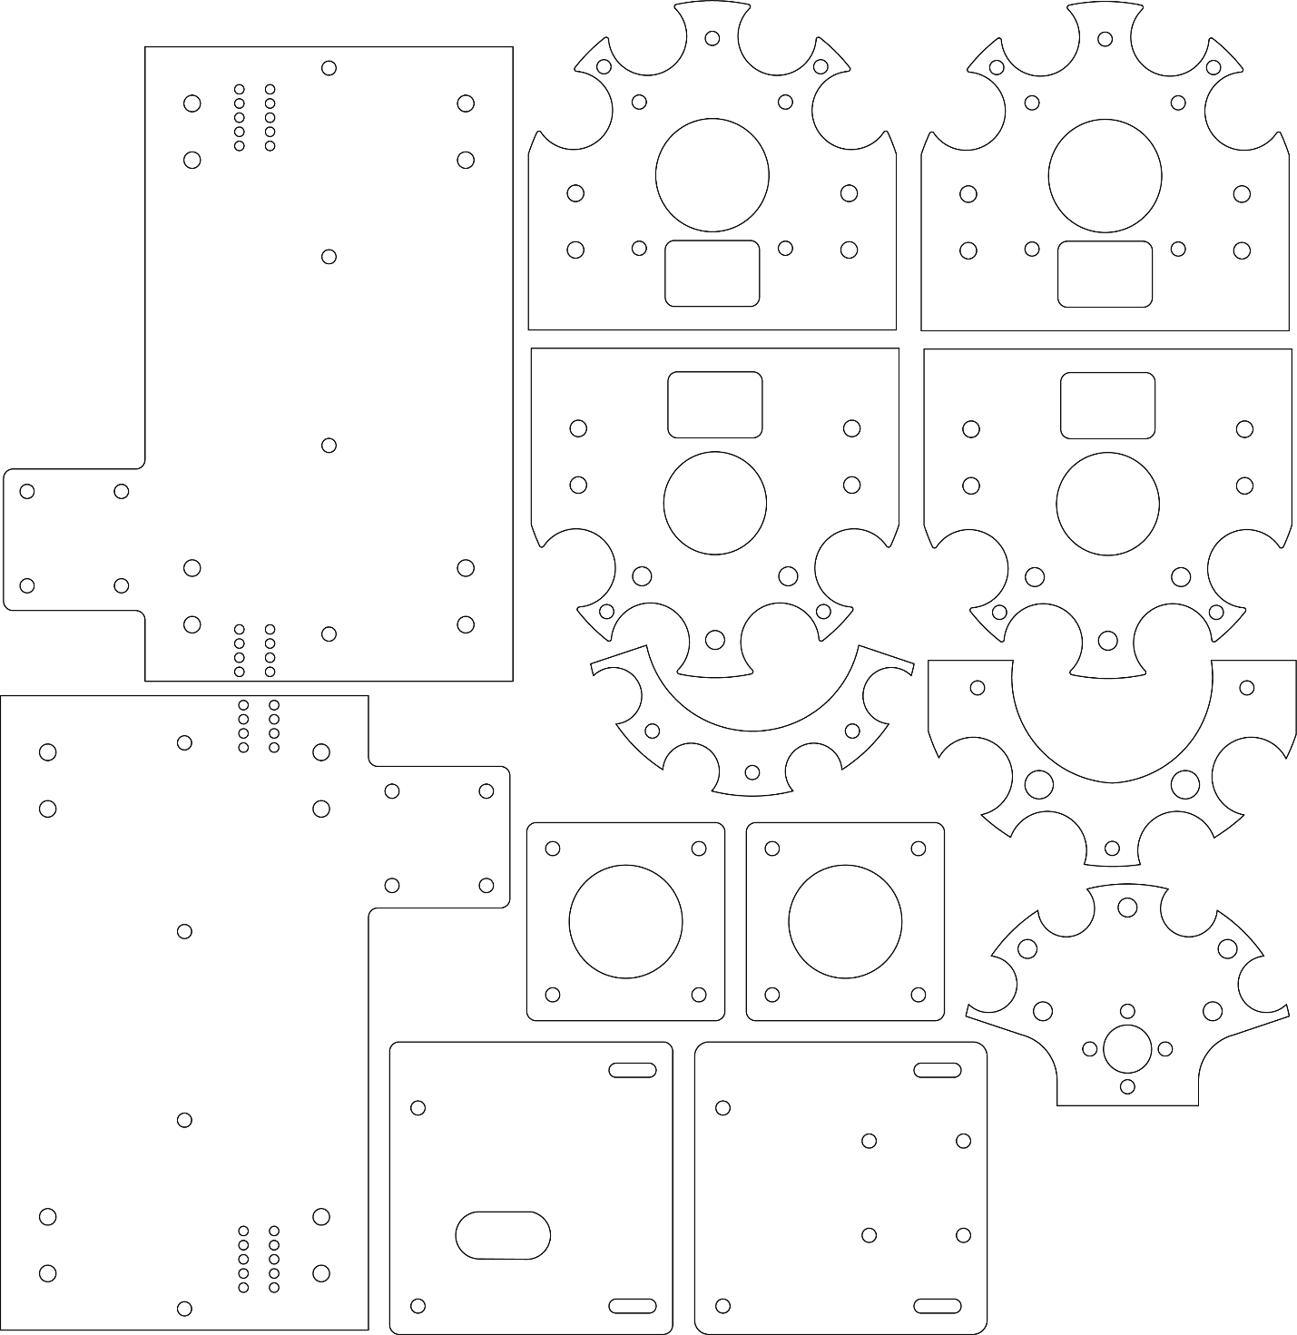

Figure 1: Parts to laser cut.

1. 3D print the parts (Knob.stl, Spacer.stl, Electronics spacer.stl and Nut holder.stl ) found on: <https://github.com/FrancisCrickInstitute/Four_channel_syringe_pump/tree/main/Manufacturing%20files/Mechanics/STL>

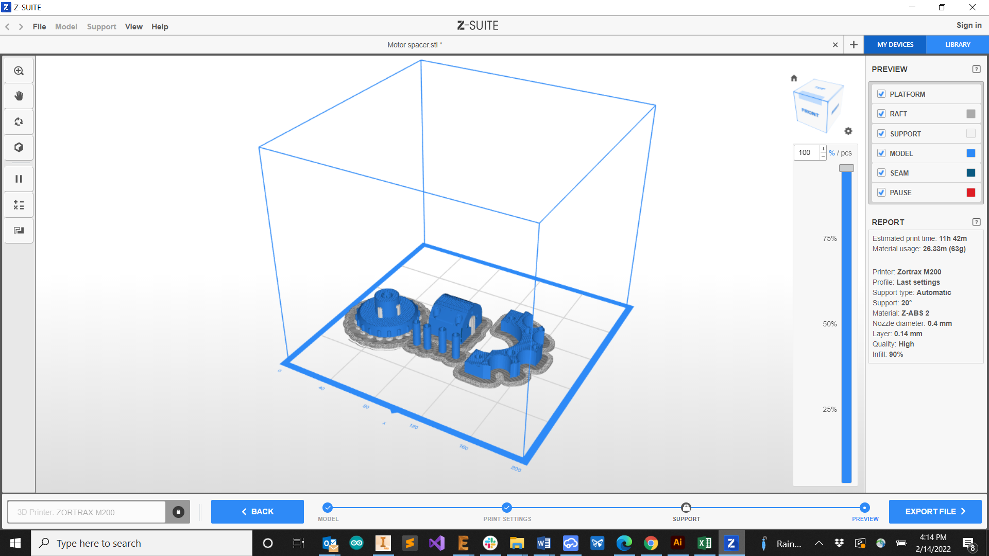

Figure 1: Parts to 3D print on the slicer simulation.

1. Send the electronics to manufacture:
   1. Go to **JLCBPCB**: <https://cart.jlcpcb.com/quote?orderType=1&stencilLayer=2&stencilWidth=100&stencilLength=100>
   2. Upload the Gerber files:
   3. Select **SMT Assembly**
   4. Upload the BOM file
   5. Upload the Pick and place file